Stripeplicity MIQ 245: I used the instructions for 12 blocks with 3 different stripes but all the same background. These examples are positioned on my design wall, not stitched. Sizes given are just the blocks, borders would make them larger. There are so many possibilities that change it up!

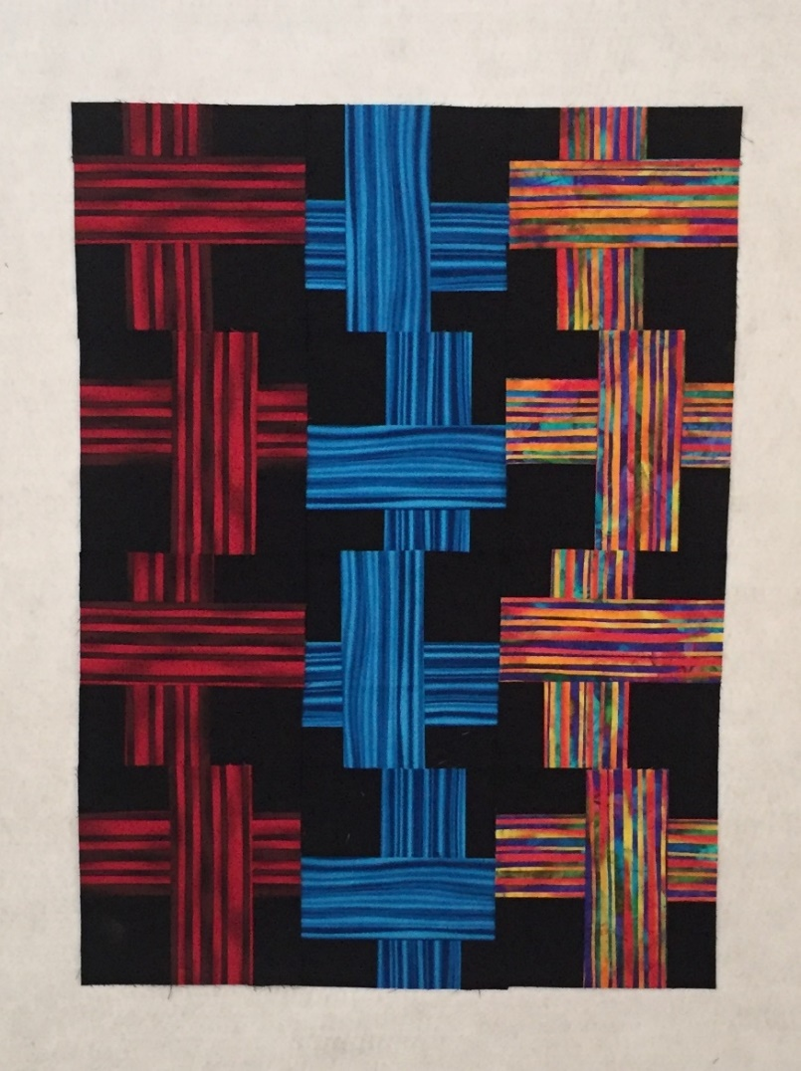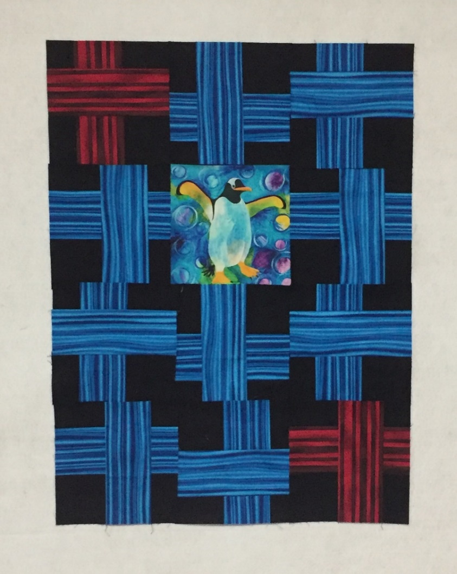
12 blocks 22.5" x 30"
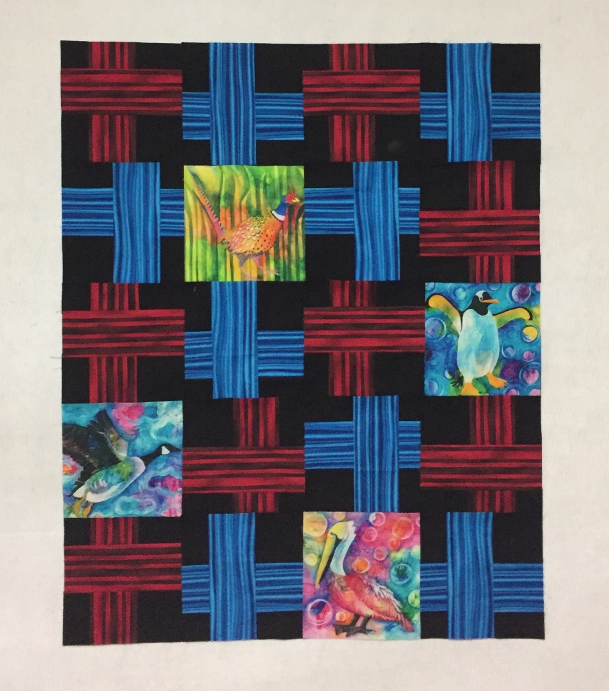
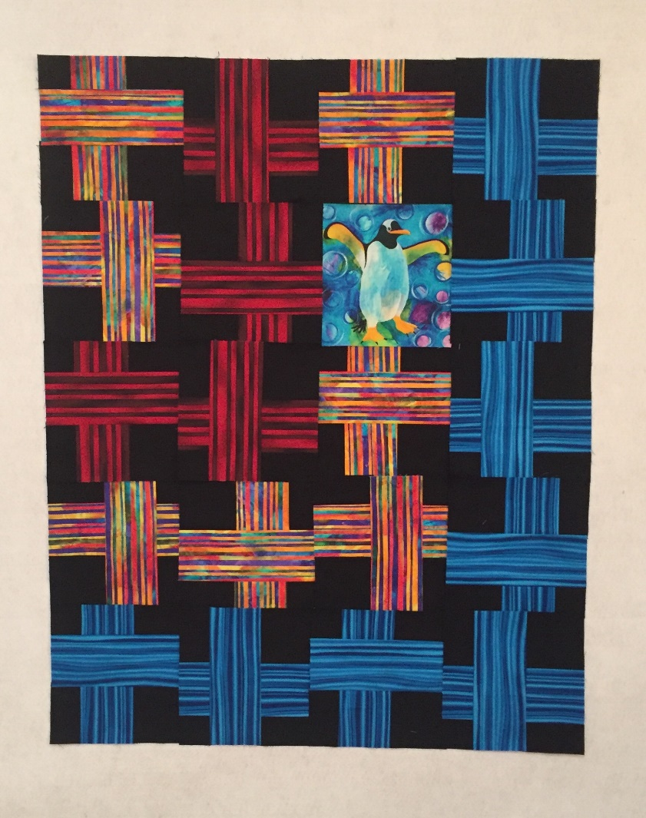

20 blocks 20 blocks 30" x 37.5"

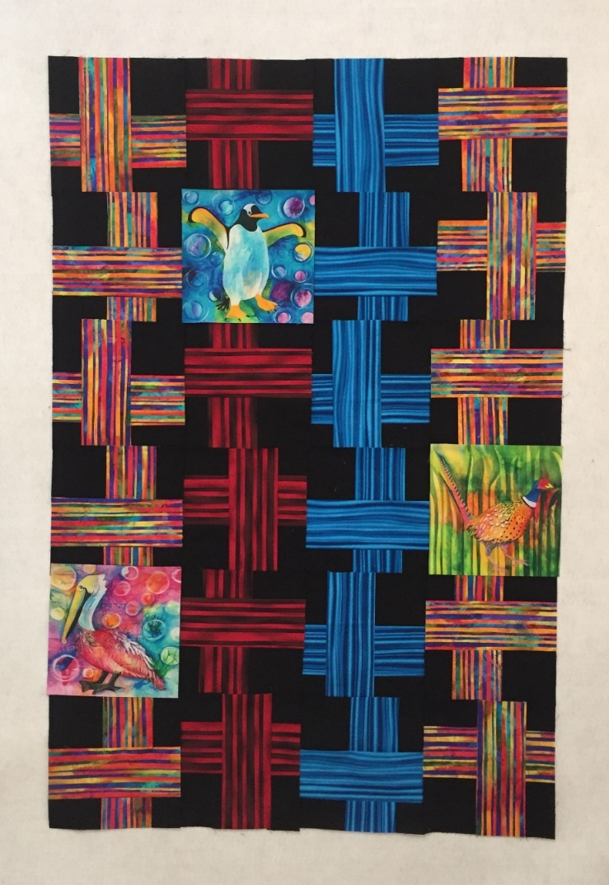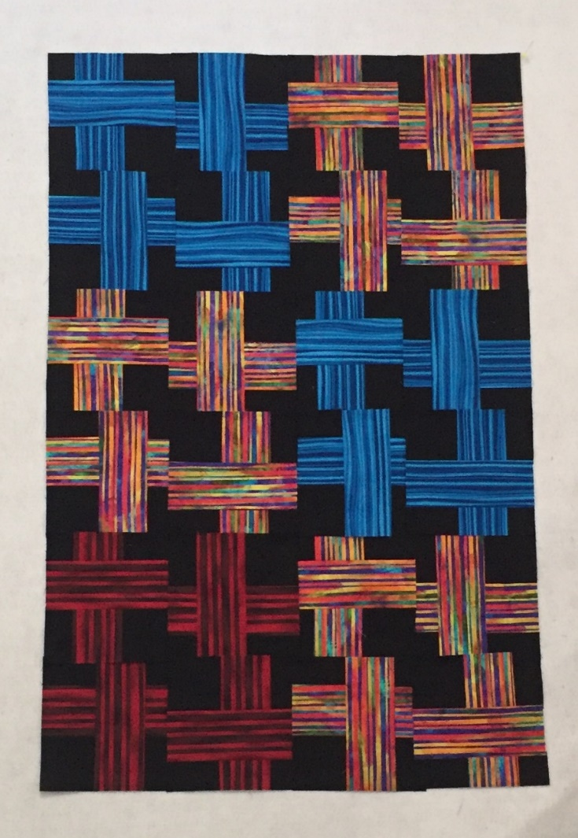
24 blocks 30" x 45"

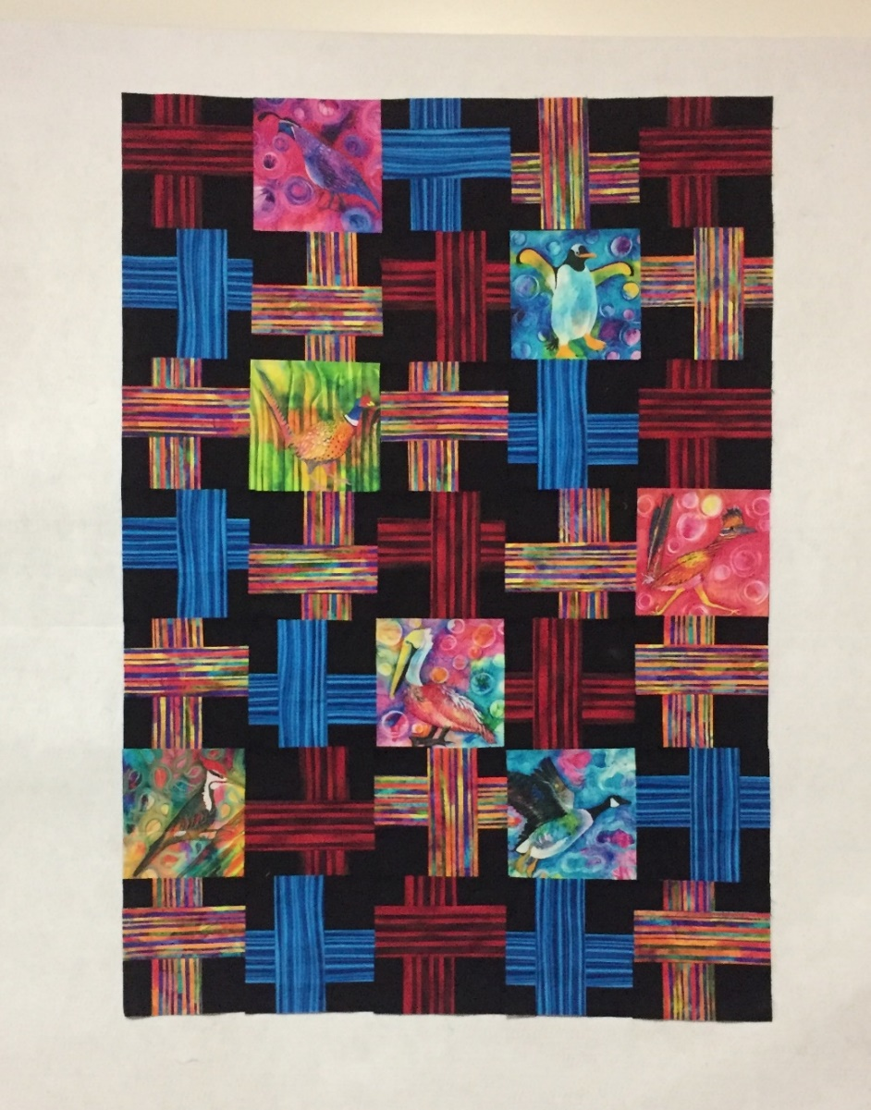
Not in pattern: 35 blocks 37.5" x 52.5" Adjust borders in pattern to fit.

