Idea #7: BQ Goes Mini Placemats: A New Look
- Both setting fabric patches were cut from a panel and were just a little too small. We cut a 2 ½” strip and stitched it to the top and bottom of the patches. It is a little narrower than the pattern calls for so these mats are a little shorter.

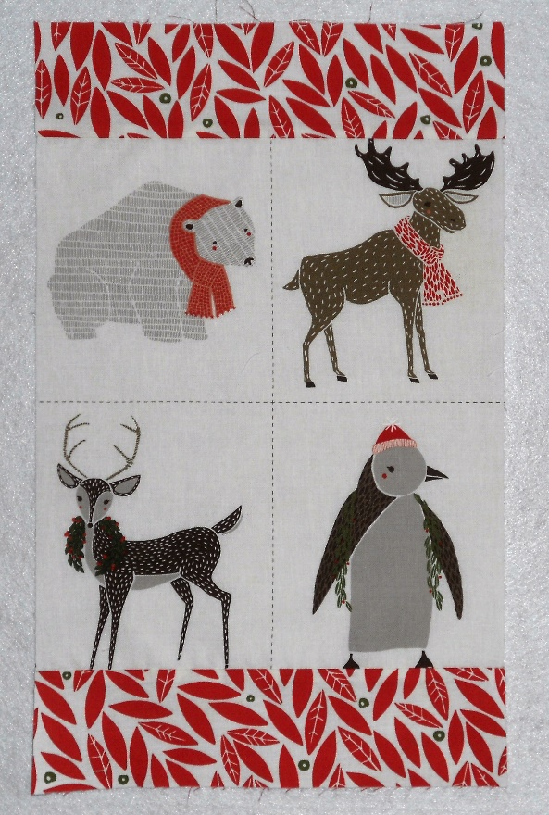

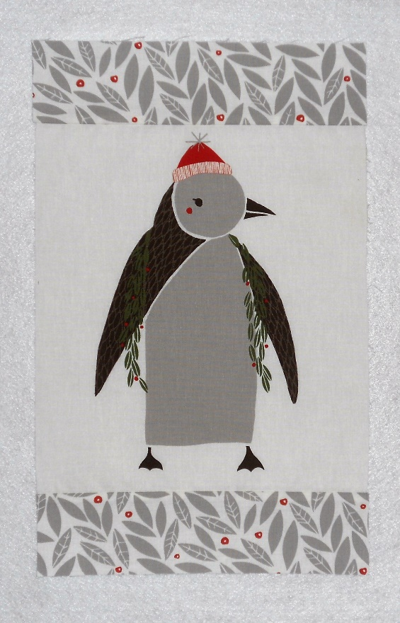
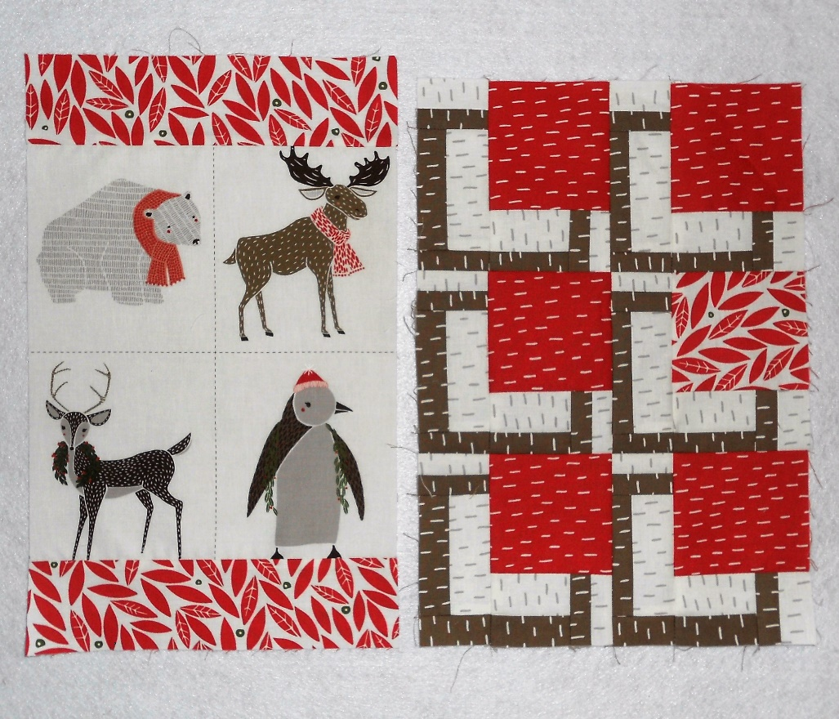
2.After stitching the top and bottom borders, trim to 14” tall as shown in the pattern. It will match the height of the Mini BQ blocks.

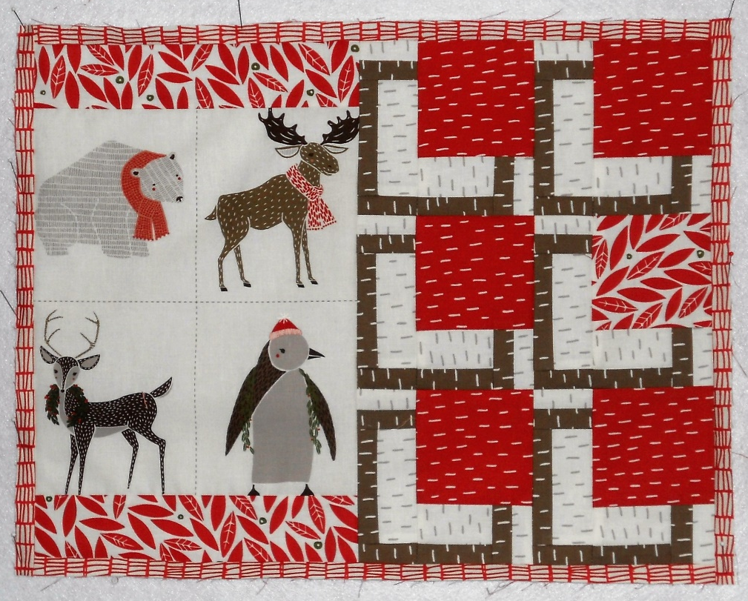
3.Stitch borders to the mat with two- ¾” cut strips. We then fused Pellon Décor Bond 809 with no batting or backing. Square the mat and stitch a tall but skinny zigzag stitch (4.5-1.5) around the mat. The last step was to use a decorate blade rotary cutter.

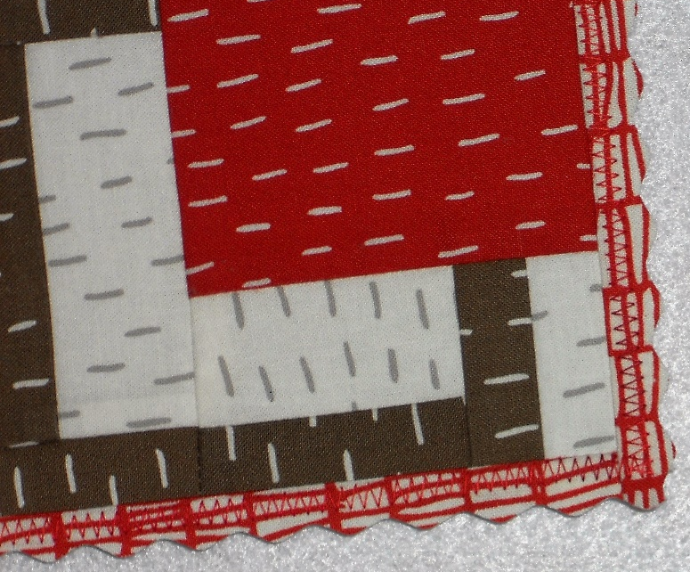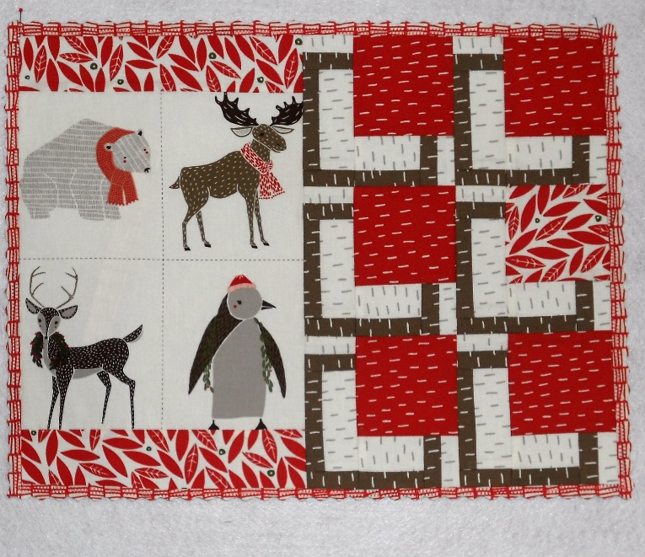

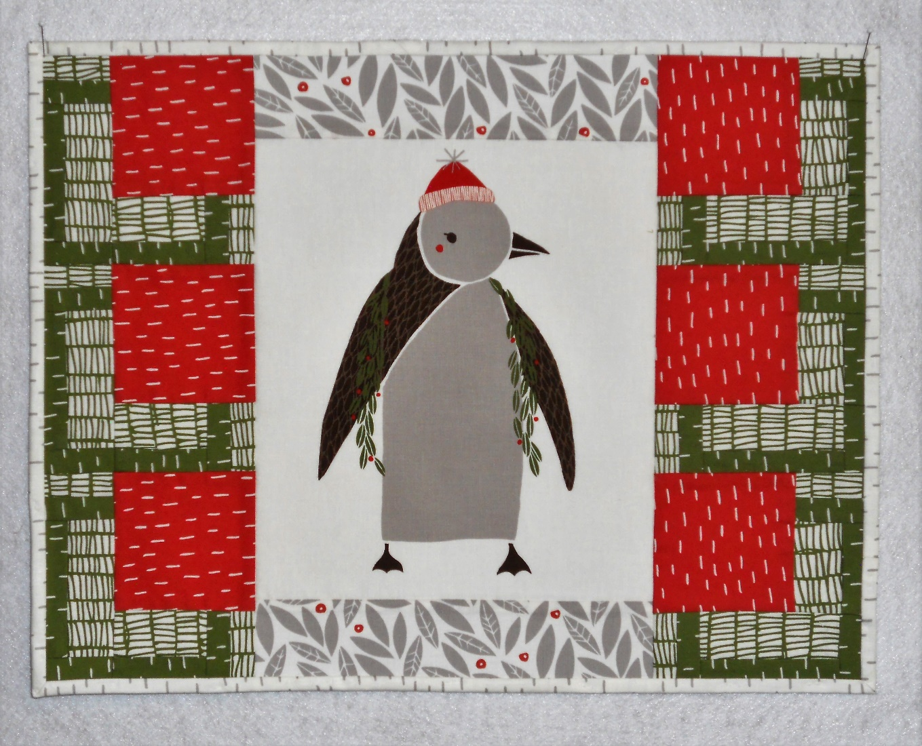
The Penguin mat is also finished with no batting or backing just Pellon Décor Bond, but used the single fold binding specified in the pattern.

I don’t plan to launder these mats, they are decorative; no batting or quilting means they go together fast!
Enjoy.

